# TASK-06[aws-vpc]

1) Create VPC with 2 private and 2 public subnets.

Step1:creating a VPC

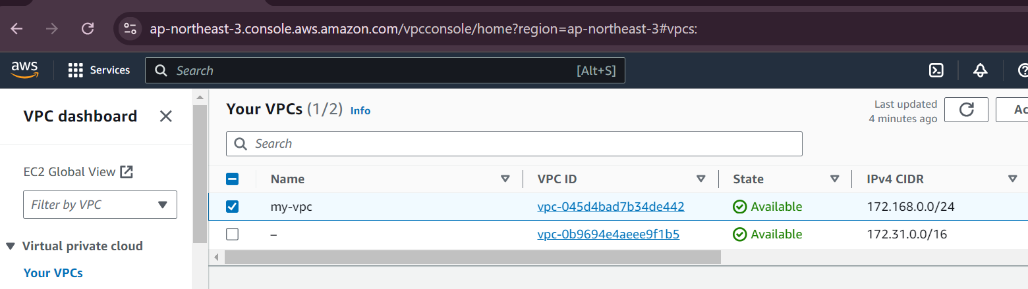

Creating two public subsets and private subsets

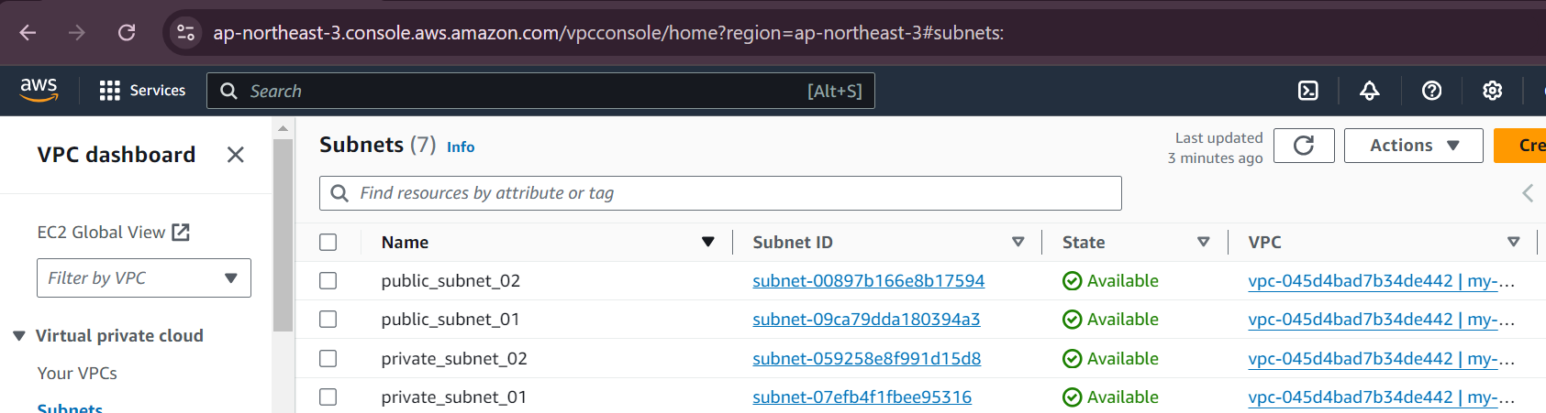

Creating the route table

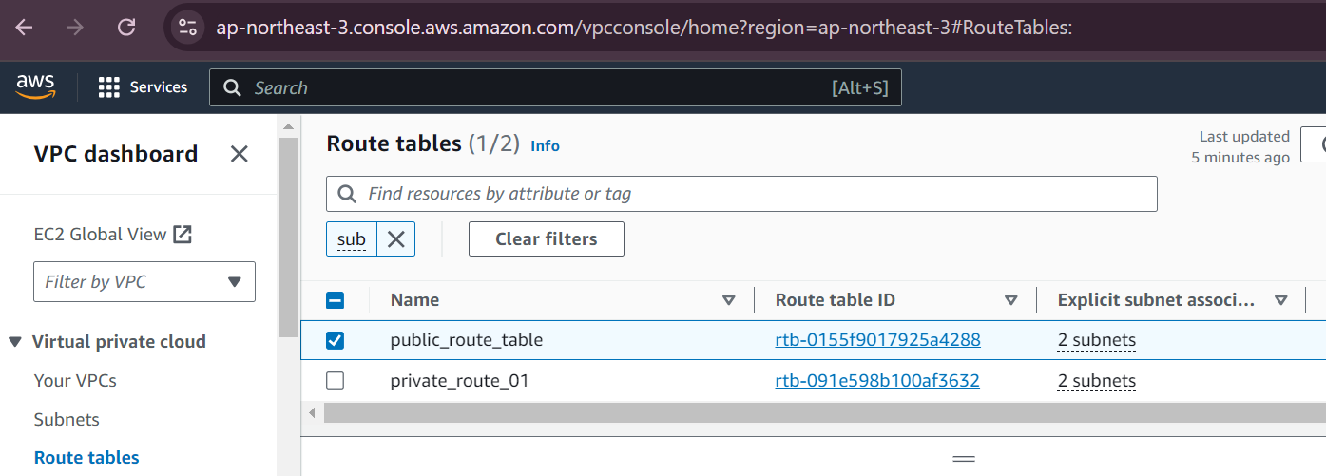

Created a IGW[internet gateway :to pyblic internet access to the public subnets]

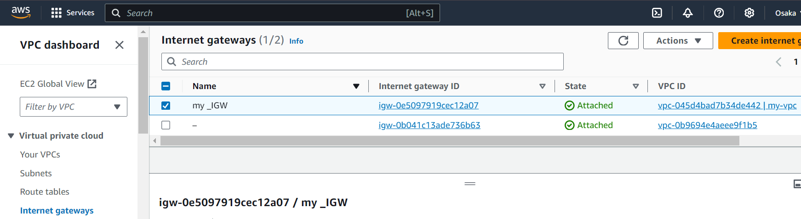

Added the Route

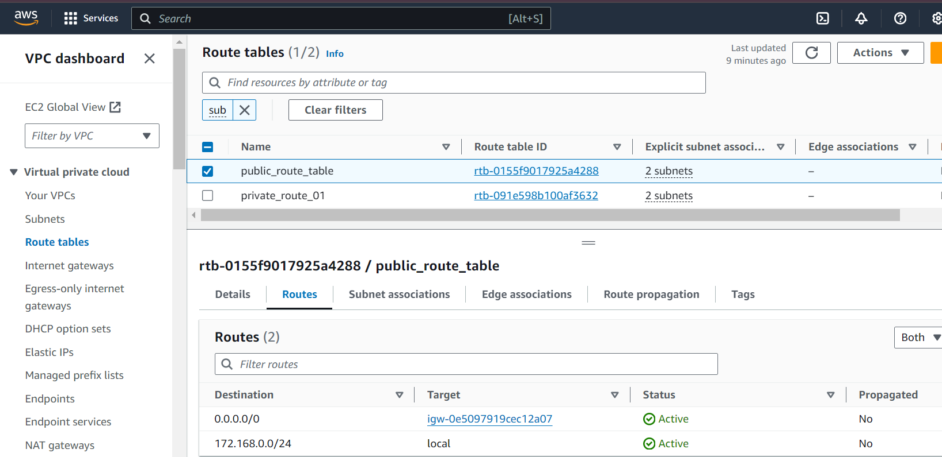

Execution:

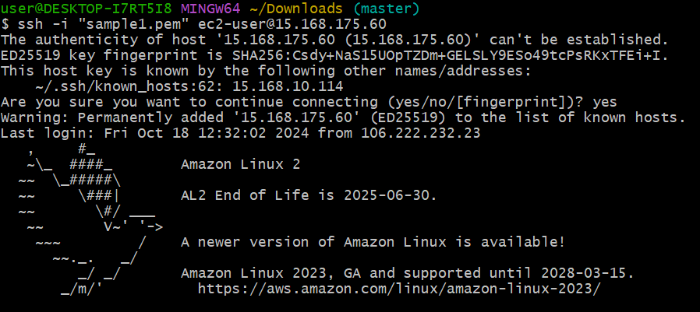

For Private subnets: 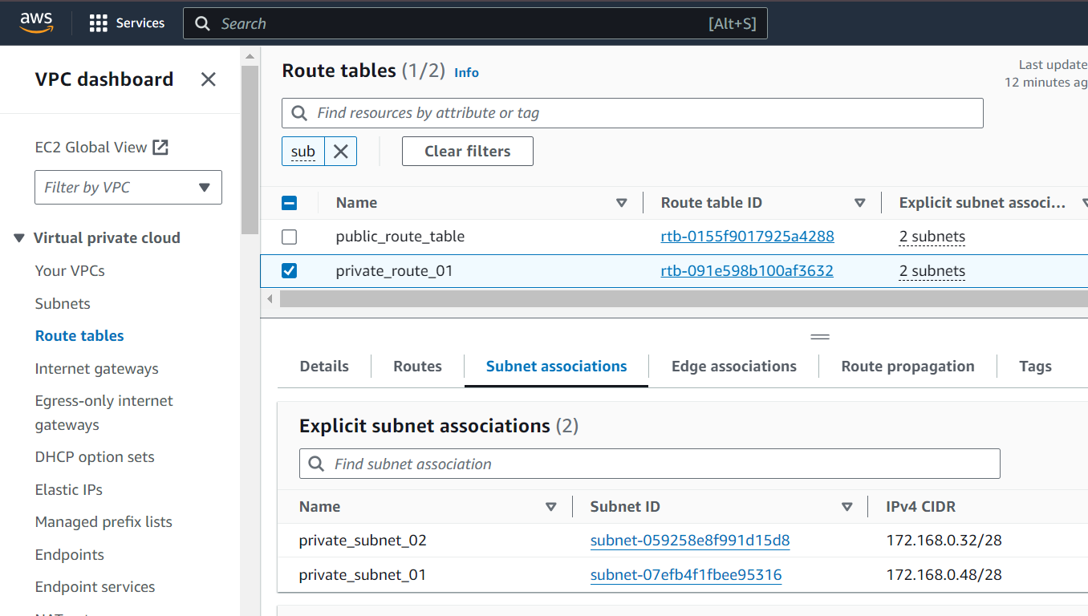

We will not privide any internet gateway for private subnets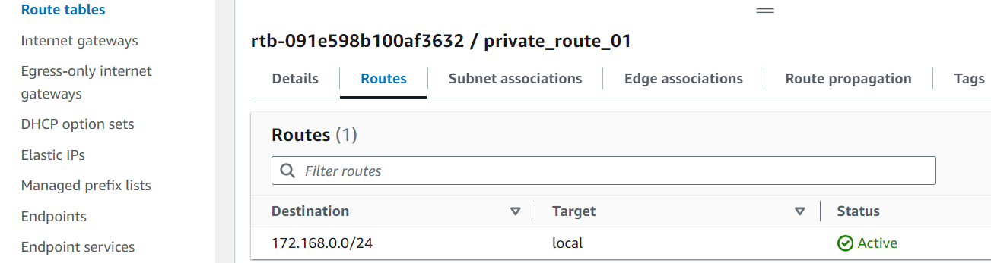

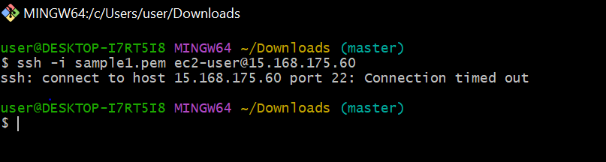

2) Enable DNS Hostname in VPC

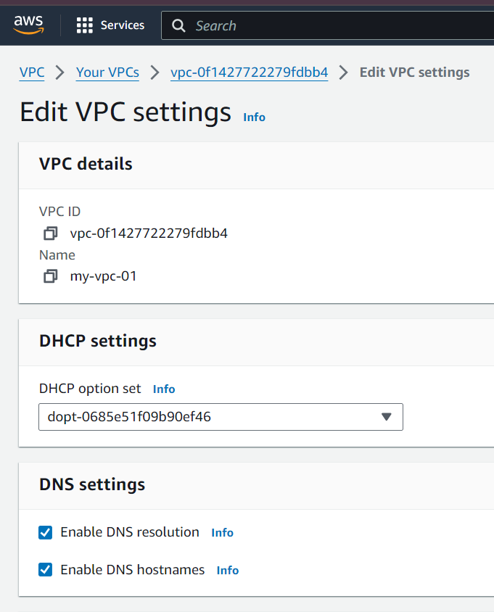

3) Enable Auto Assign Public ip in 2 public subnets

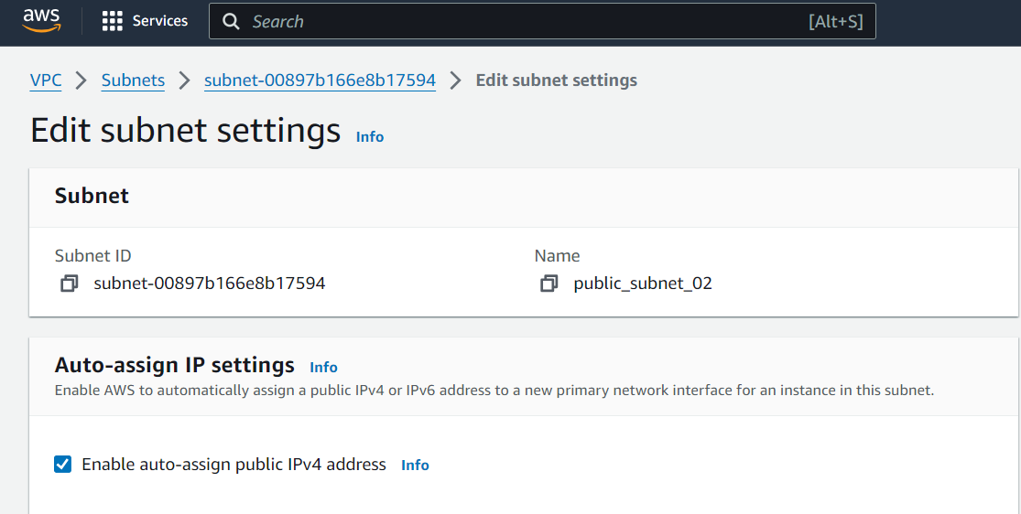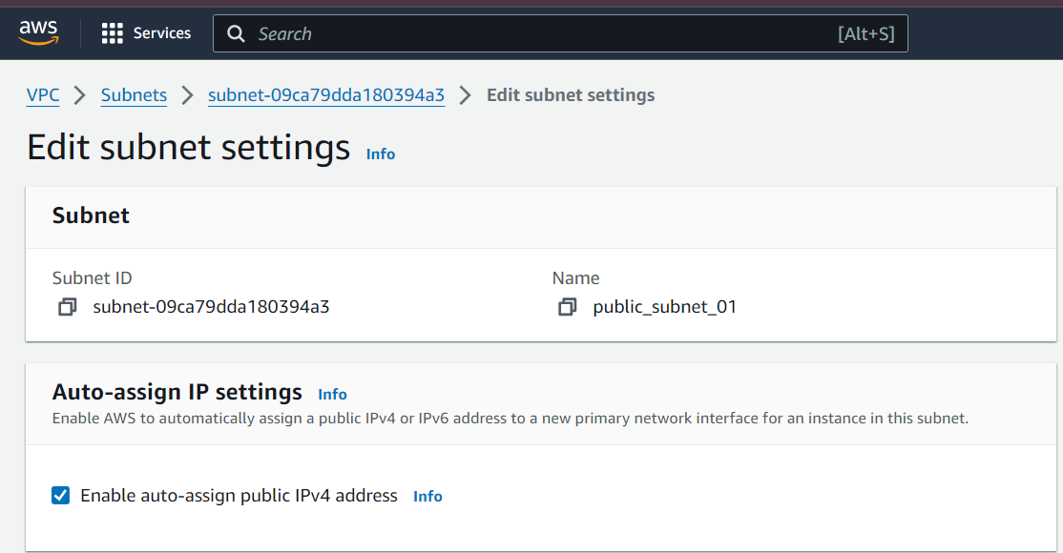

4) Add 2 private subnets in private route table

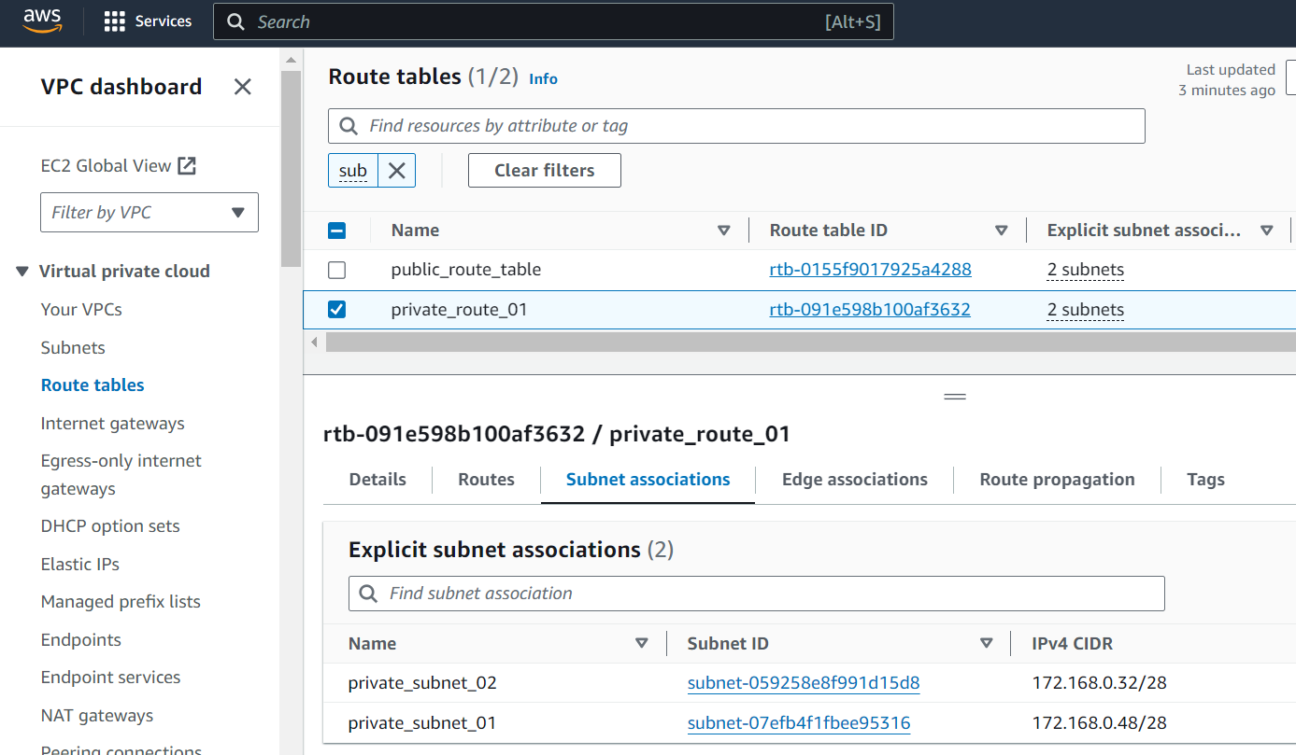

5) Add 2 public subnets in public route table

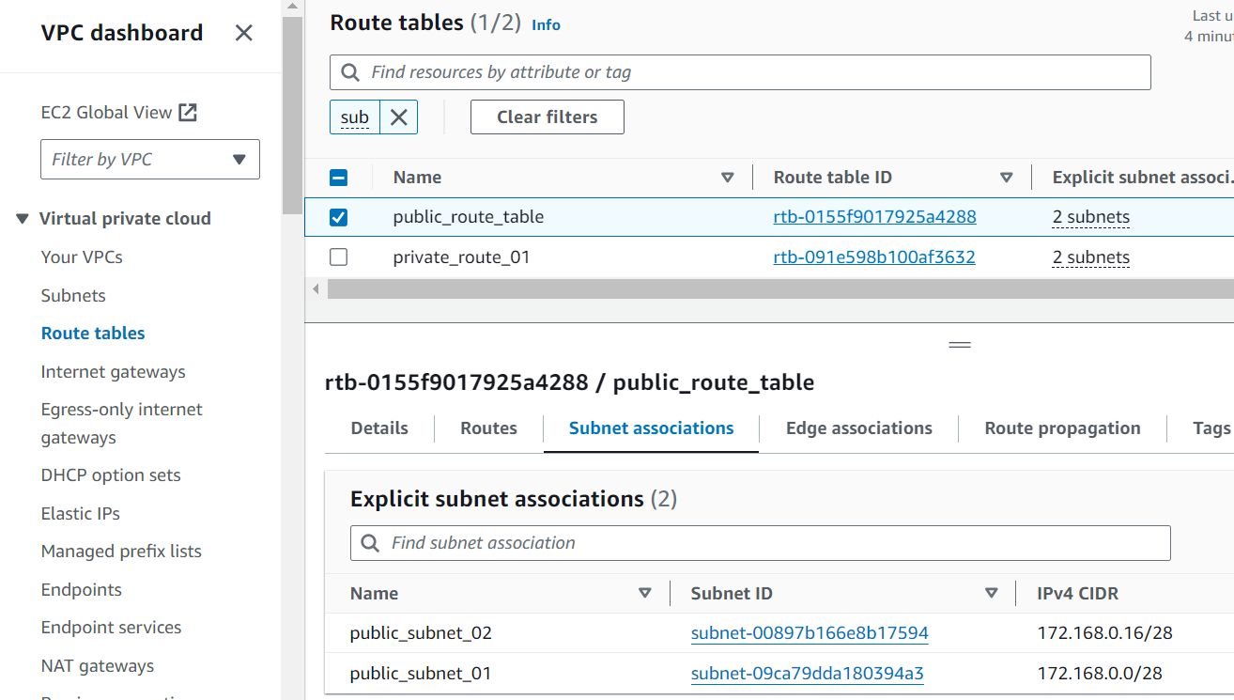

6) Public route table will have the routes to internet and local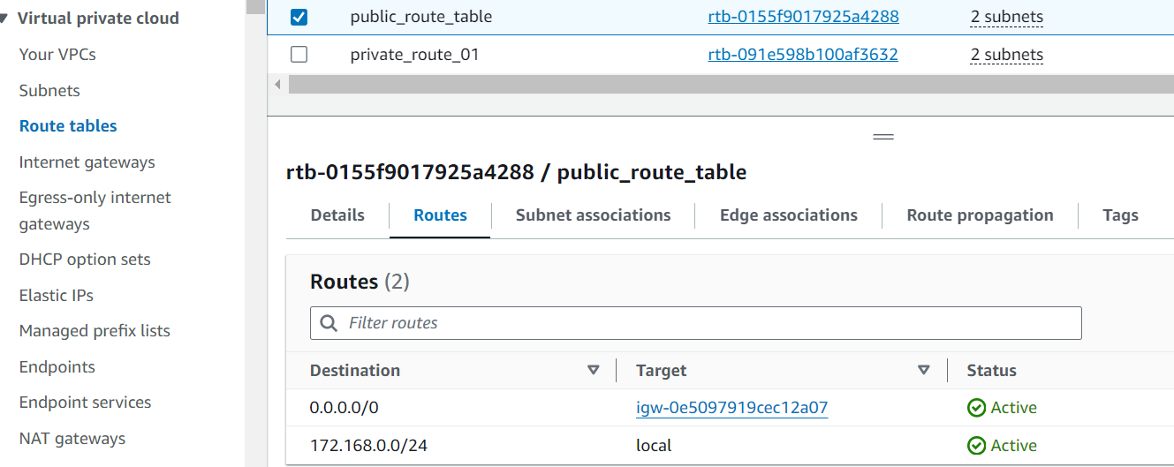

7) Create Ec2 in public subnet with t2micro and install php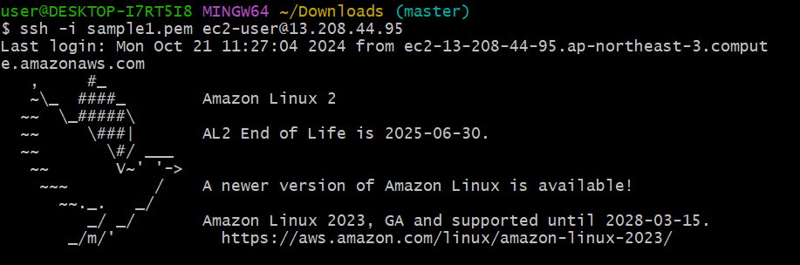

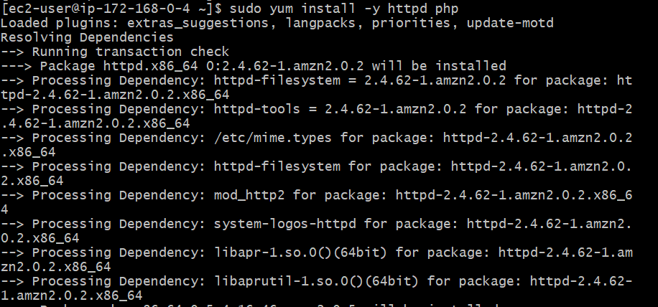

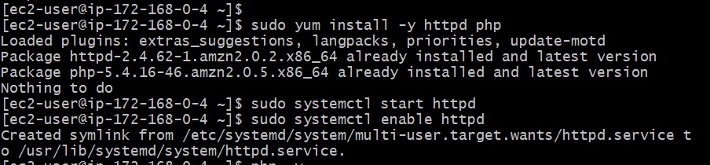

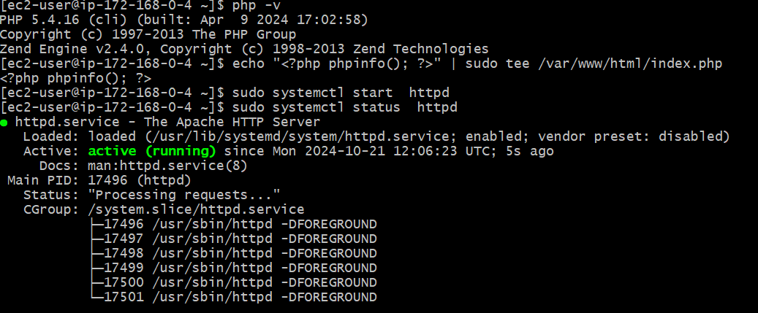

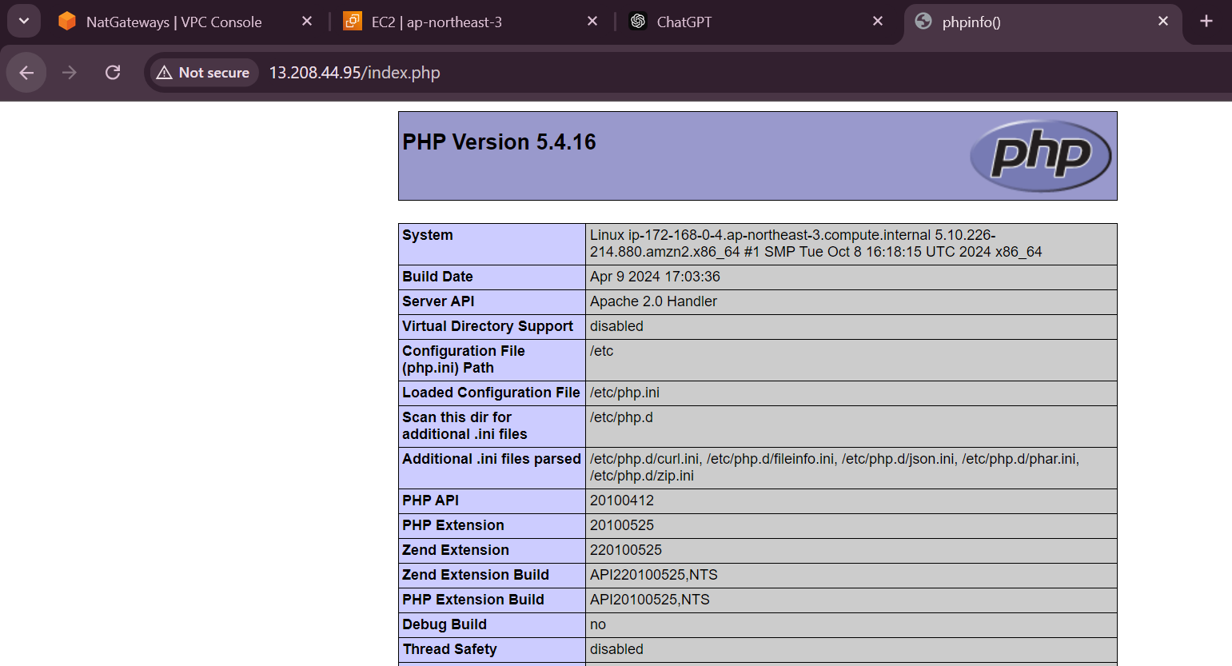

8) Configure Nat gateway in public subnet and connect to private Instance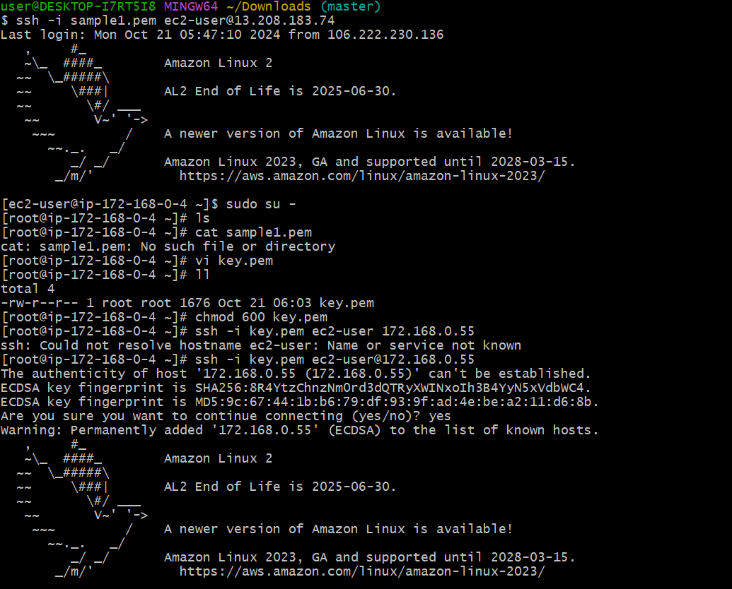

Created Nat gateway

Added NAT gateway in the route table

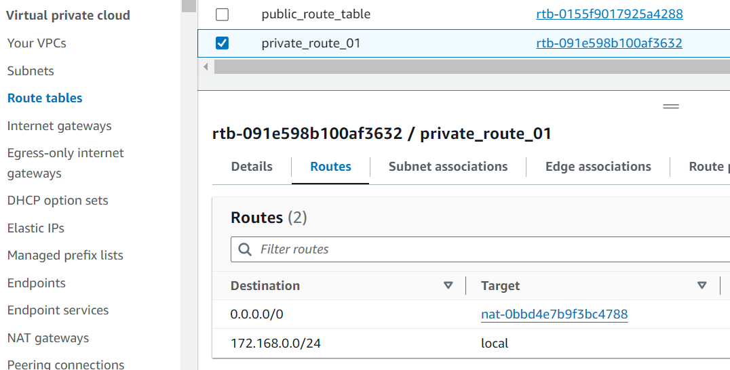

With the help of

NAT gateway able to provide internet access to the private subnet

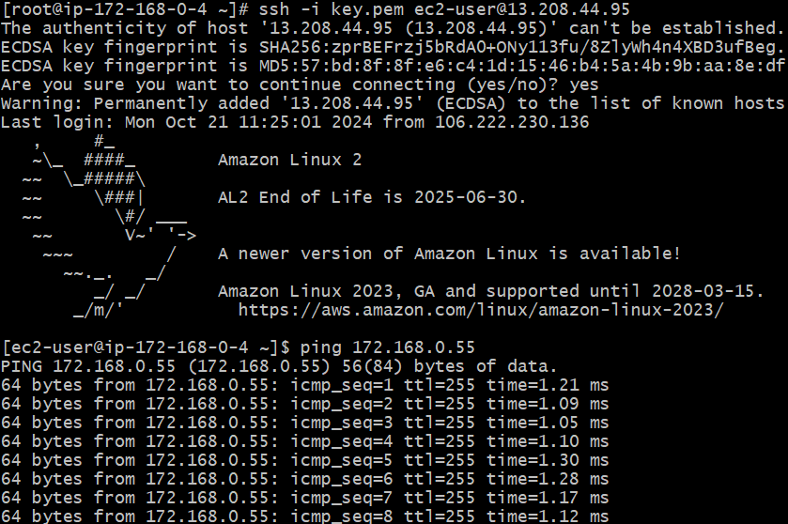

9) Install Apache Tomcat in private ec2 and deploy a sample app.

Assigned the internet to private ec2 using Nat gateway



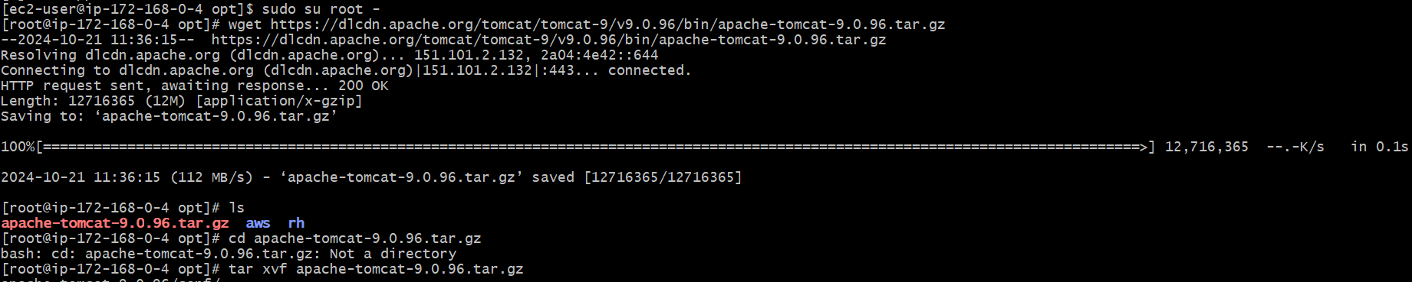





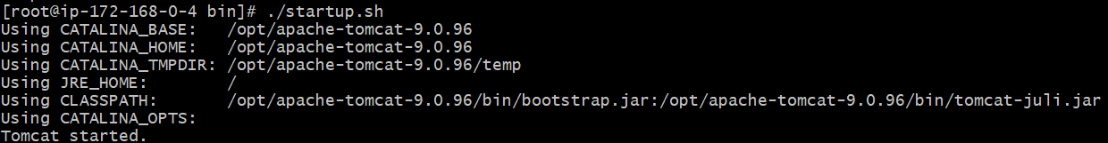

Deploying in webapps sample app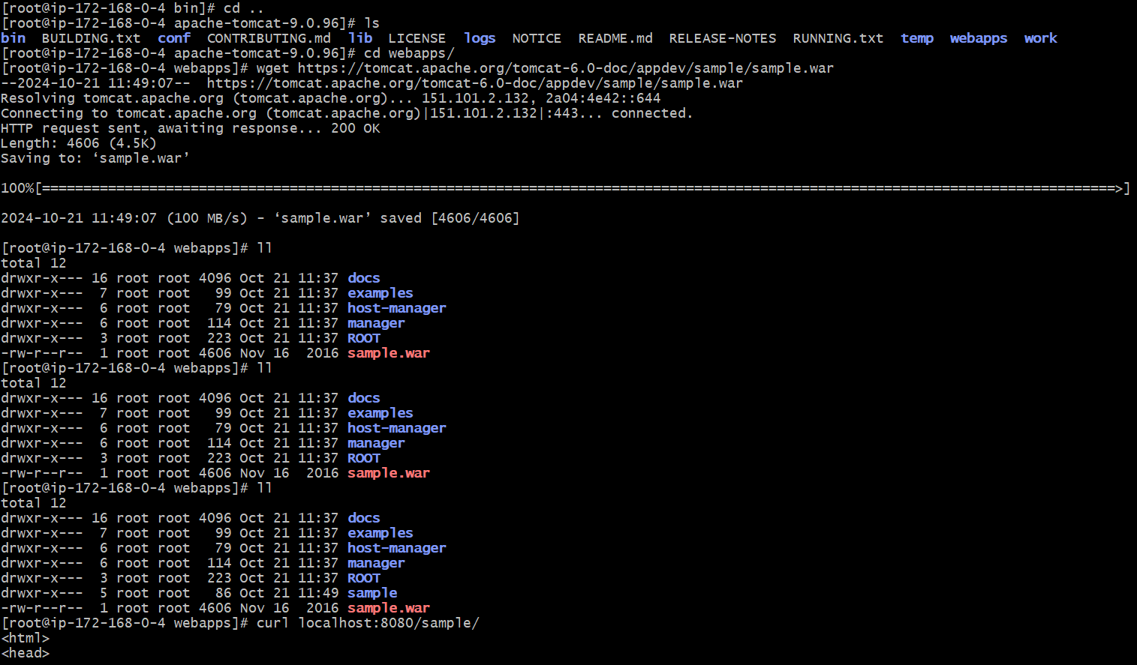

10) Configure VPC flow logs and store the logs in s3 and cloudwatch.

Step:1

Creating the s3 bucket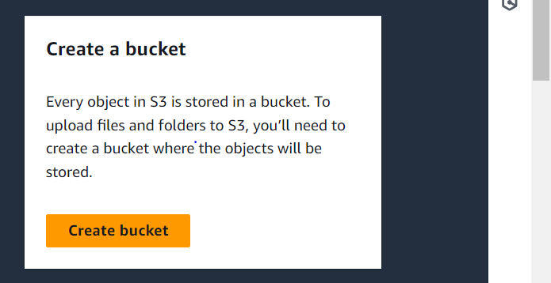

Created a flow log

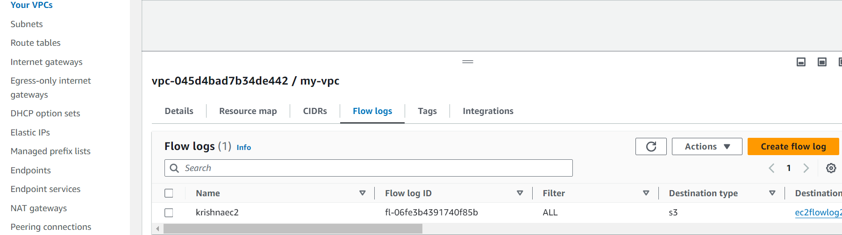

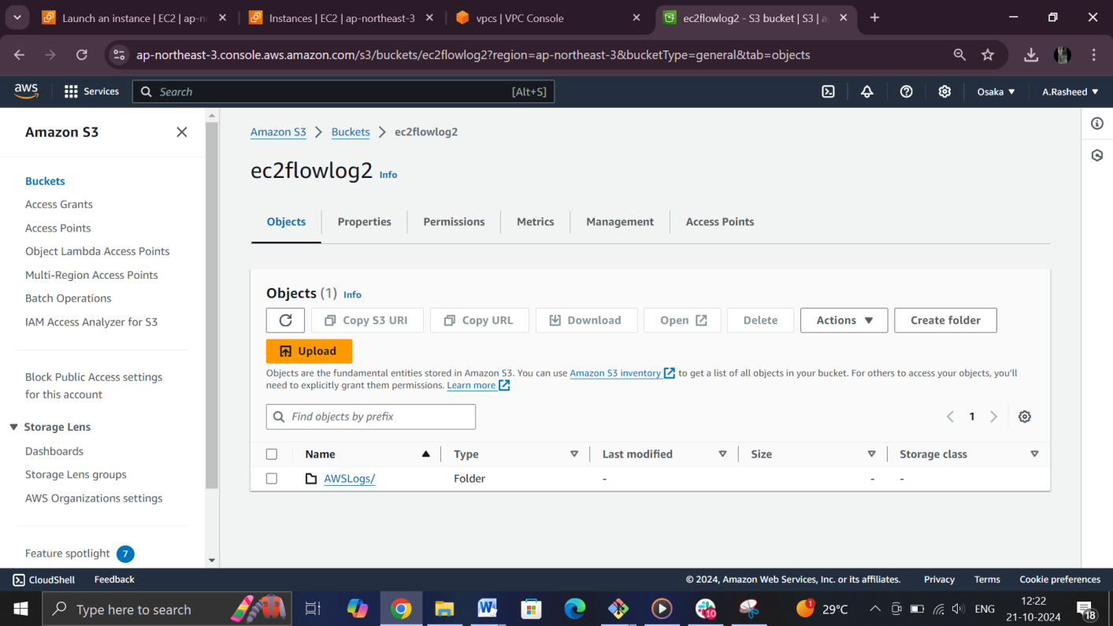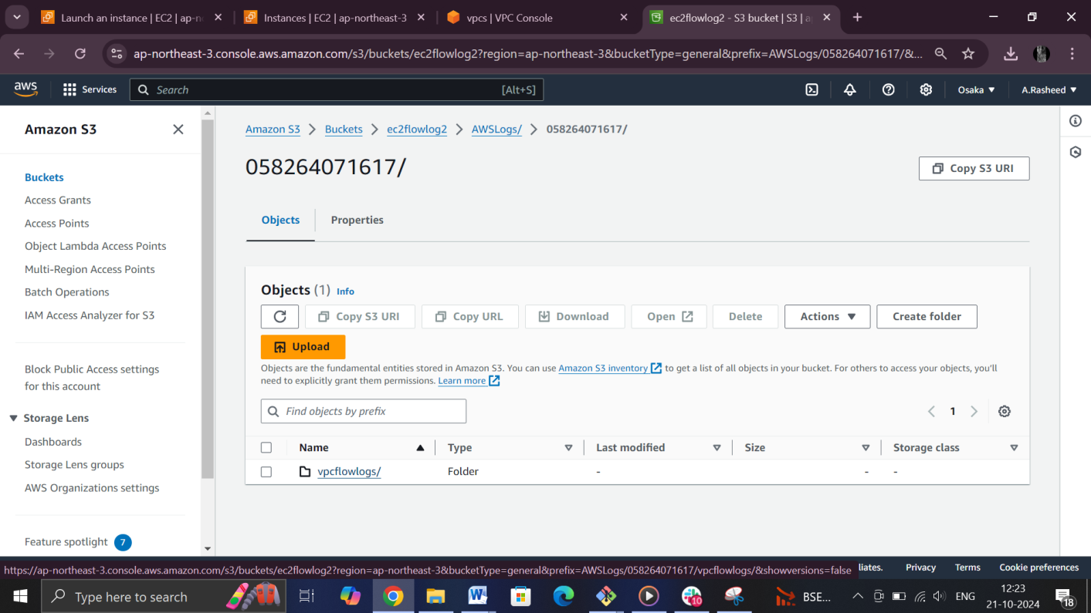

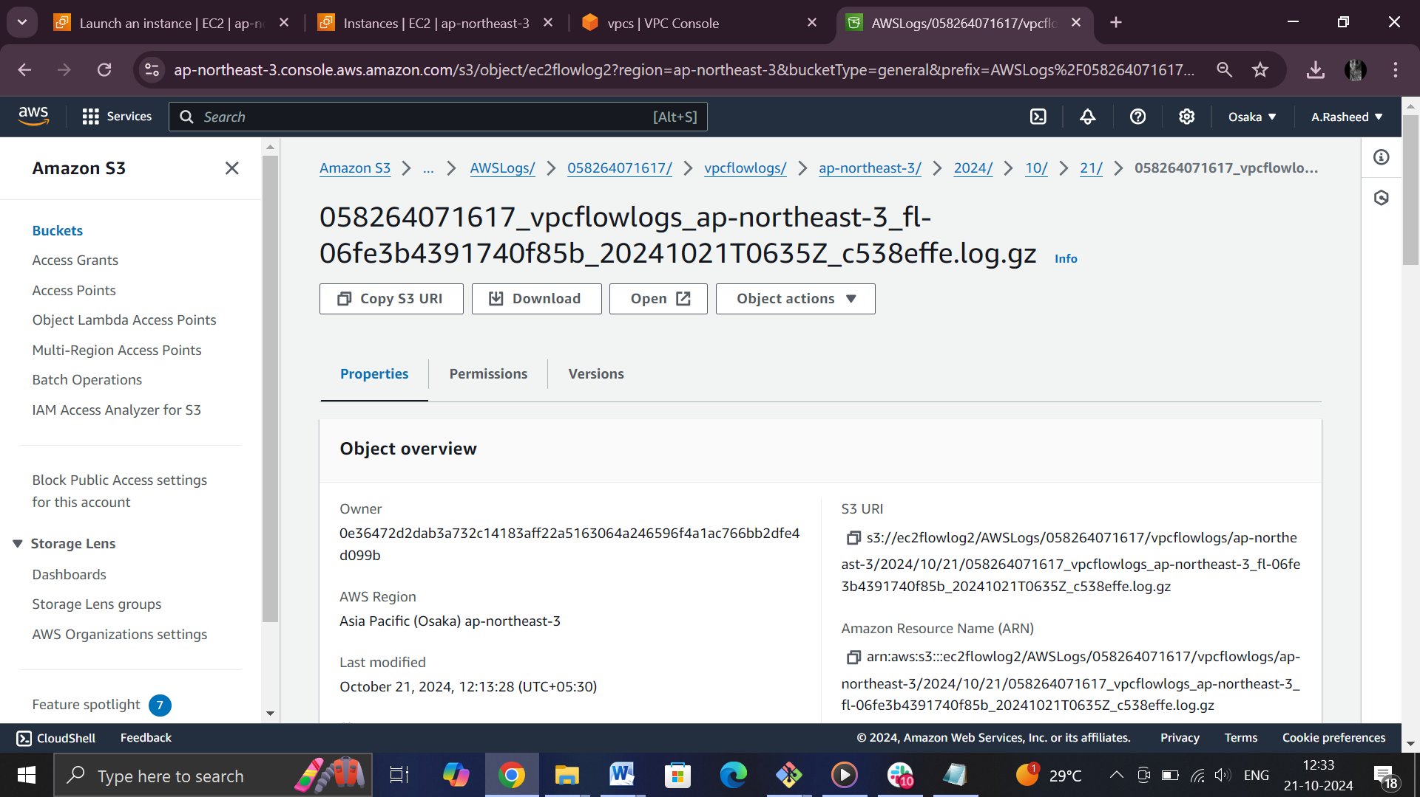

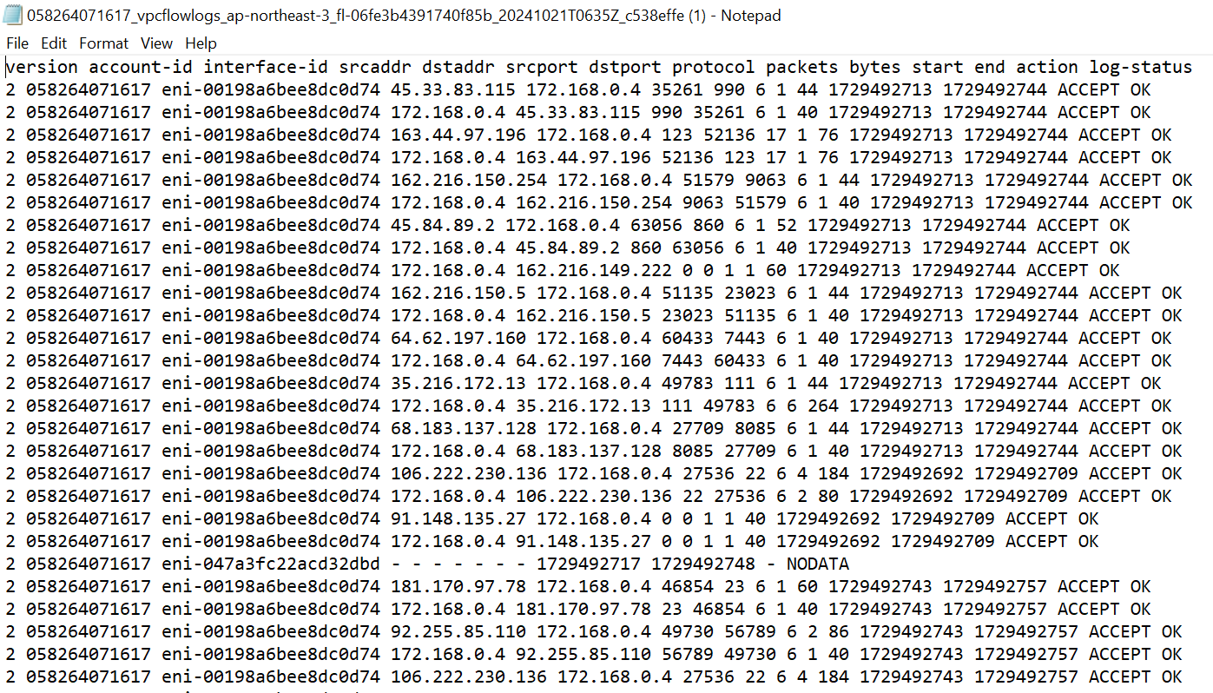

Cloudwatch

Created a log flow in vpc

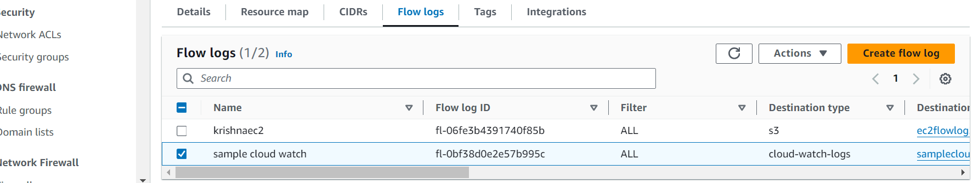

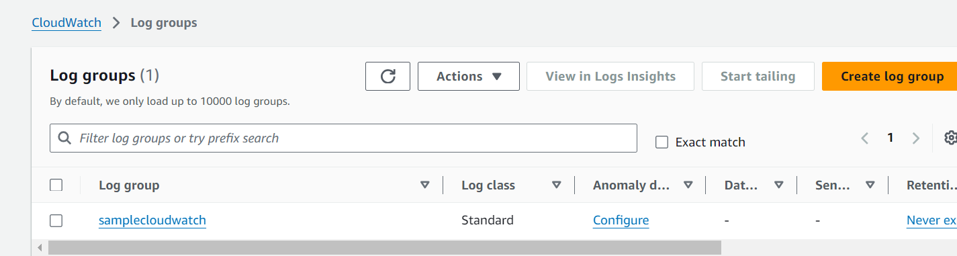

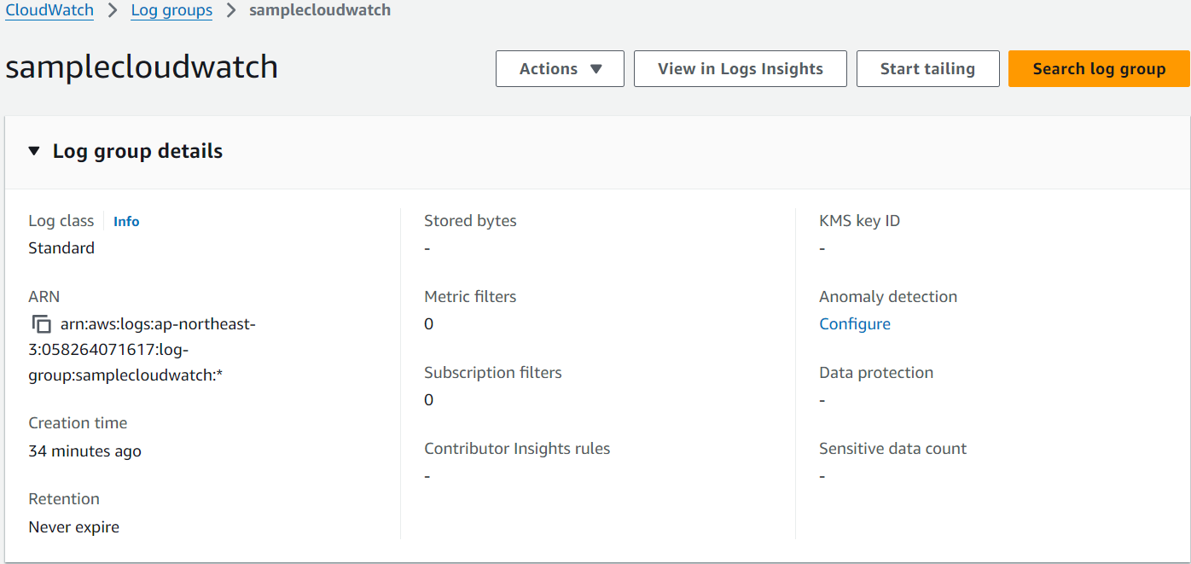

IAM role

Roles and trust policy created

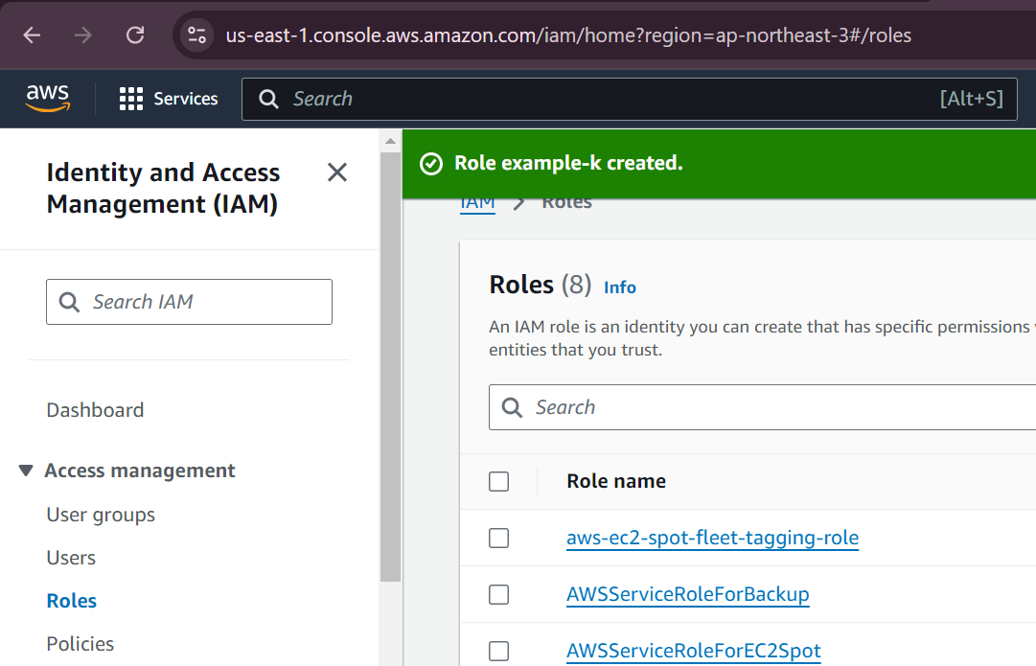

Create a cloud watch

